# Automate the Web Application (TestNG).

## Output:

### Facebook Login Page:

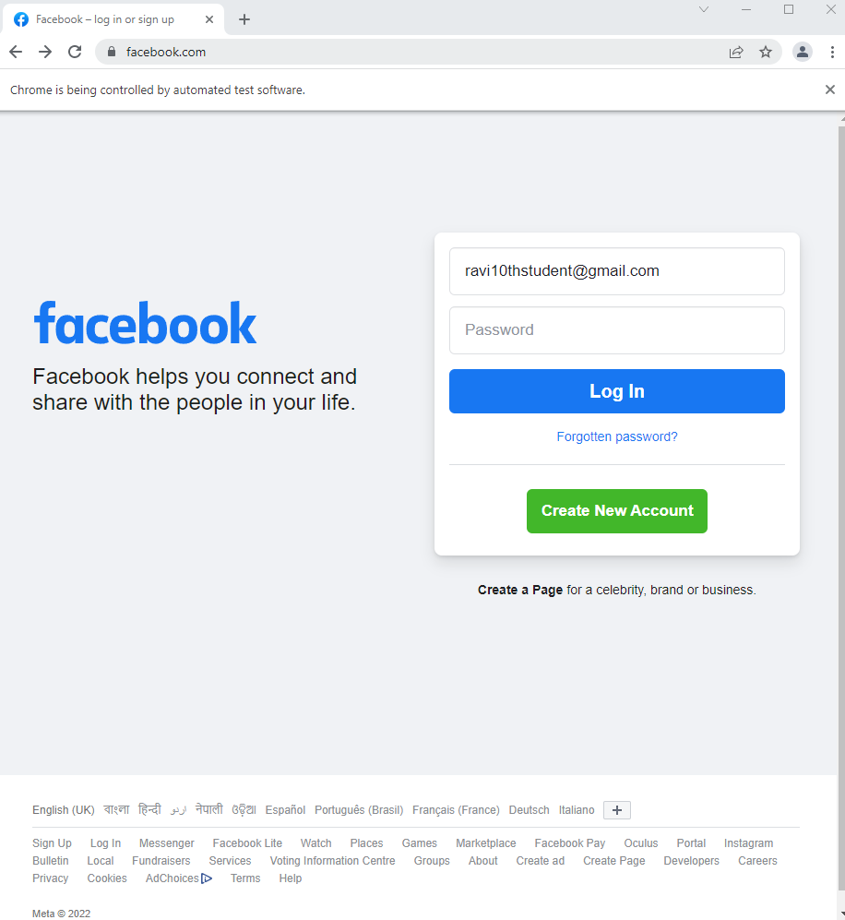

### After Wrong Password Login:

### 

### Console Output (TestNG):

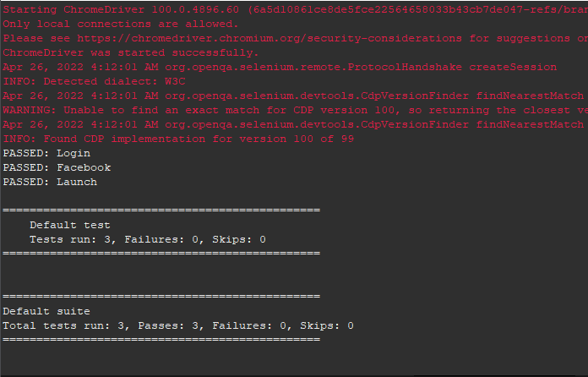

### Junit:

